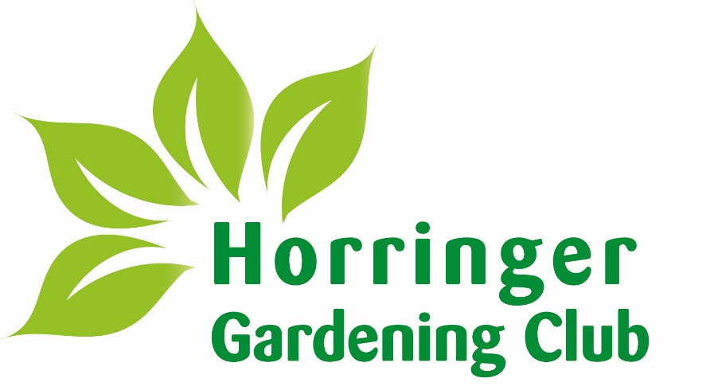

Schedule of the 139th
Annual Show

HORRINGER COMMUNITY CENTRE

Monday 13th JULY 2026
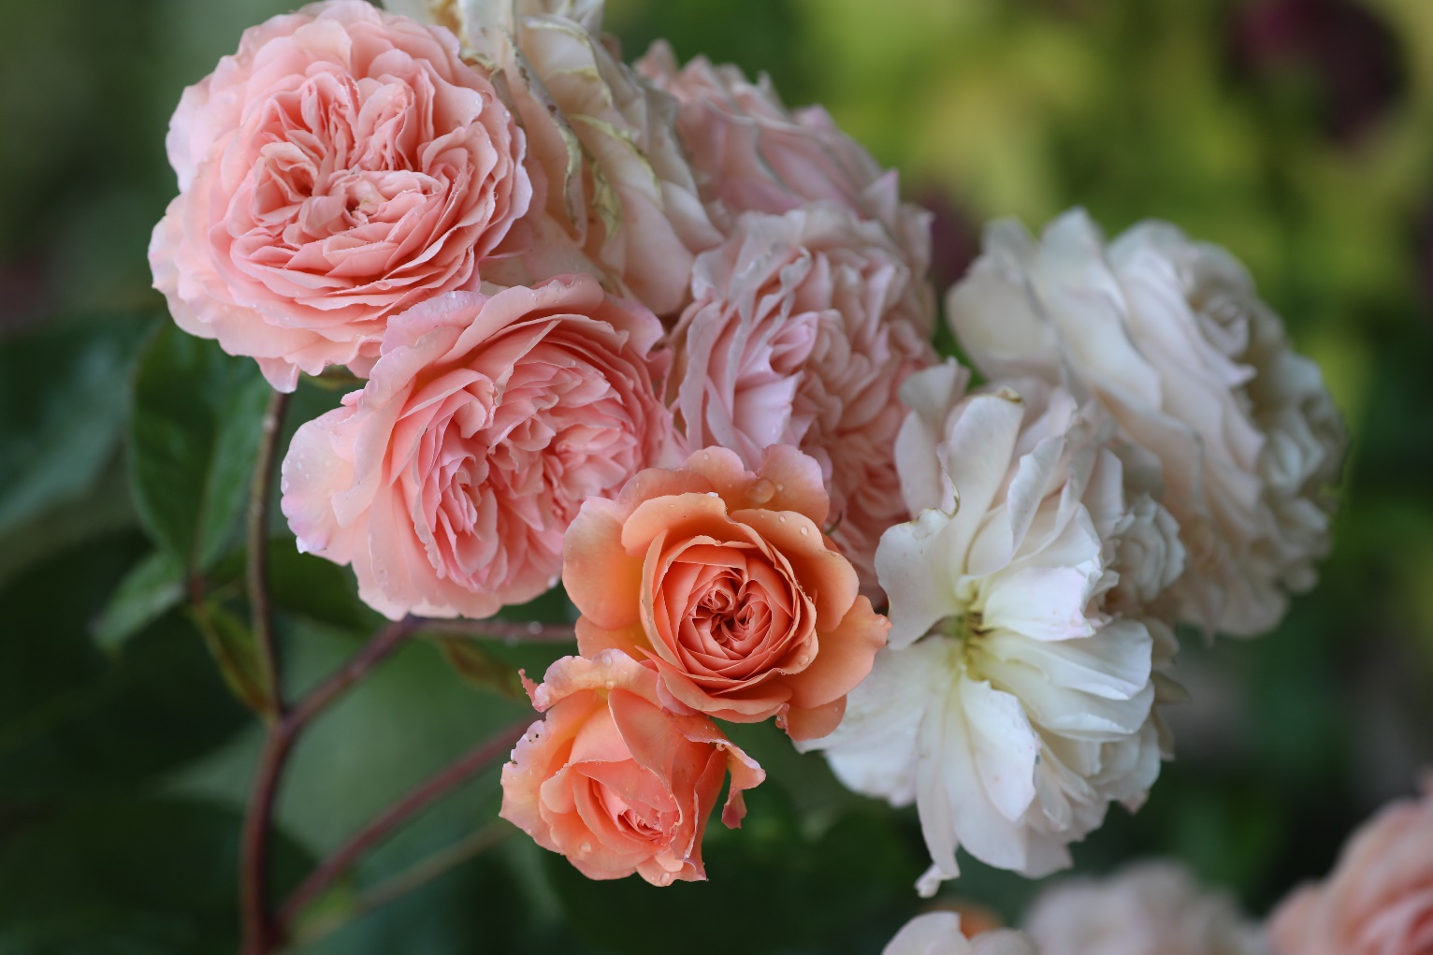
7 pm

All completed entry forms to be returned by Wednesday 8th July.

By email pollybarfoot@aol.com
Or postal to Polly Barfoot c/o 7 The Chestnuts, Horringer, Bury St Edmunds, IP29 5SD.

ENTRY SECTIONS & CLASSES

SECTION 1 - FRUIT - THE COLLINS TROPHY
Class
1 Gooseberries, 12, any variety.
2 Blackcurrants – 100 grams (approx.) 4 oz.
3 Redcurrants, (strings) – 100 grams (approx.) 4 oz.
4 Raspberries, (stalks attached) 12.
5 A collection of 3 distinct types of fruit on a plate.

SECTION 2 - VEGETABLES - THE SILVER CHALLENGE CUP -
Class
6 Carrots, any variety 5.
7 Beans (Runner, French, Broad, any variety), 6 pods.
8 Lettuce, any variety, 1.
9 Peas, 6 pods.
10 Potatoes (any colour or any shape), 5.
11 Courgettes, 4 (4” – 6” optimum).
12 Tomatoes, 4, any variety.
13 Cucumber, 1 any variety.
14 Radishes, bunch of 6 with tops, any variety.
15 Rhubarb, 3 sticks, eating quality – leaves trimmed.
16 Beetroot, 3, any variety with tops.

SECTION 3 - FLOWERS (except roses) - THE BRABROOK CUP
Class
17 Annuals mixed 1 container.
18 Antirrhinums, 3 spikes.
19 Dahlia, 1 stem, any variety.
20 Dahlias, 6 blooms, any variety.
21 Herbaceous perennials, any variety, max 9 blooms.
22 Herbaceous perennials, any variety 1 stem.
23 Pinks, 3 sprays, any variety.
24 Fragrant Pink, 1 stem.
25 1 Hosta Leaf.
26 Annual sweet peas, with own foliage if desired – 1 container.

SECTION 4 - ROSES - THE SILVER ROSE BOWL
Class
27 A pink or red rose, 1 stem with own foliage.
28 A white or yellow rose, 1 stem with own foliage.
29 A rose of any other colour not listed above, 1 stem with own foliage.
30 Roses, 3 single stems.
31 Fragrant rose, 1 stem.

SECTION 5 - POT PLANTS, SUCCULENTS Etc. - THE LAINSON CUP
Class
32 A fuchsia in a pot.
33 An Orchid in a pot.
34 A fern or foliage plant in a pot.
35 A cactus in a pot.
36 A succulent in a pot.
37 A pelargonium in a pot.
38 Cut fuchsia, 1 stem any variety.
39 Cut flowering shrubs, 3 stems any varieties.
40 Cut herbs gathered in a container (max 5 varieties).

SECTION 6 - FLORAL ART - THE FLORAL ART CUP & FRIARY CUP
Class
41 "Tea for Two" an arrangement in a teapot.
42 A floral arrangement in a basket to be given as a gift.
43 “By the Sea” a petite arrangement, max 12” in any direction.

SECTION 7 - PRESERVES Etc. - THE CENTENARY CUP
Class
44 Jar of jam, 1lb or 12 oz.
45 Jar of fruit jelly.
46 Jar of fruit curd.
47 Jar of marmalade, 1lb or 12 oz.
48 Jar of chutney or pickles.
49 Jar of honey.

SECTION 8 - COOKING - THE JOAN WHITING MEMORIAL TROPHY
Class
50 Muffins, 4.
51 Cheese Straws, 6.
52 Lemon drizzle cake, own recipe.
53 A white loaf of bread, made by any method.
54 Chocolate Brownies, 4.

SECTION 9 – PHOTOGRAPHY (Camera or Mobile Phone) – THE NATIONAL TRUST SALVERS
Class
55 The Beauty of Plants.
56 An Action Shot.
57 Trees, Woods and Forests.
58 Wildlife in the Garden.
59 Beautiful Gardens.
60 Fungi.

SECTION 10 - CRAFTS - THE BANK CUP
Class
61 An article of knitting, embroidery or canvas work.
62 A handmade soft toy suitable for a child.
63 A picture by any medium, max 17” x 13” including frame.
64 A bird box or feeder made from recycled materials.
65 A item of jewellery.
66 An article made from wood, ceramics, or pottery.

SECTION 11 - PATIO ENHANCEMENT – THE HUTCHINSON CUP
Class
67 A window box not exceeding 25” in length.
68 A container of growing flowering plants, suitable for standing on a patio.
69 A container of growing alpine plants, max 5 varieties.
70 A container of growing herbs, max 5 varieties.

SHOW RULES

1. All flowers, fruit and vegetables must be grown by the Exhibitors except for flower arranging classes.
2. No Exhibitor may enter more than ONE entry in any Class.
3. All exhibits in sections 5 must have been in the possession of the exhibitor for the preceding two months.
4. All entries in sections 5 to 9 must be the exhibitor’s own work.

NOTES FOR EXHIBITORS OF FLOWER, FRUIT AND VEGETABLE CLASSES
Flowers and Ornamental plants
For assessing the merits of most exhibits of flowers and some exhibits of pot plants condition and uniformity are the important criteria.
Condition: An exhibit is in good ‘condition’ when the material of which it consists is in the most perfect stage of its life.
Uniformity: An exhibit is ‘uniform’ when items of which it consists of are alike in age, size and form.
To avoid confusion, note that Herbaceous perennials are non woody plants that die back to the ground at the end of a growing season. In the spring, the plant will produce shoots from its root system and develop its aboveground green stems and leaves. Plants such as Lavender, Fuchsias and Buddleia are not therefore herbaceous perennials.
Assessing the merits of fruit and vegetables.
For fruit and vegetables, condition, size, colour and uniformity are usually the main criteria taken into consideration.

Enquiries concerning entries to:

Polly Barfoot
E: pollybarfoot@aol.com
M: 07971 149919

