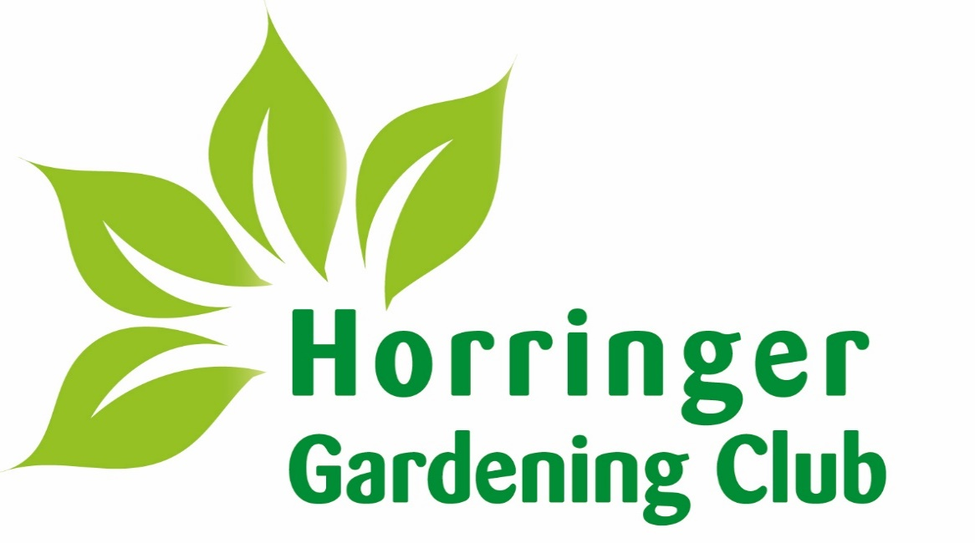

PROGRAMME 2026

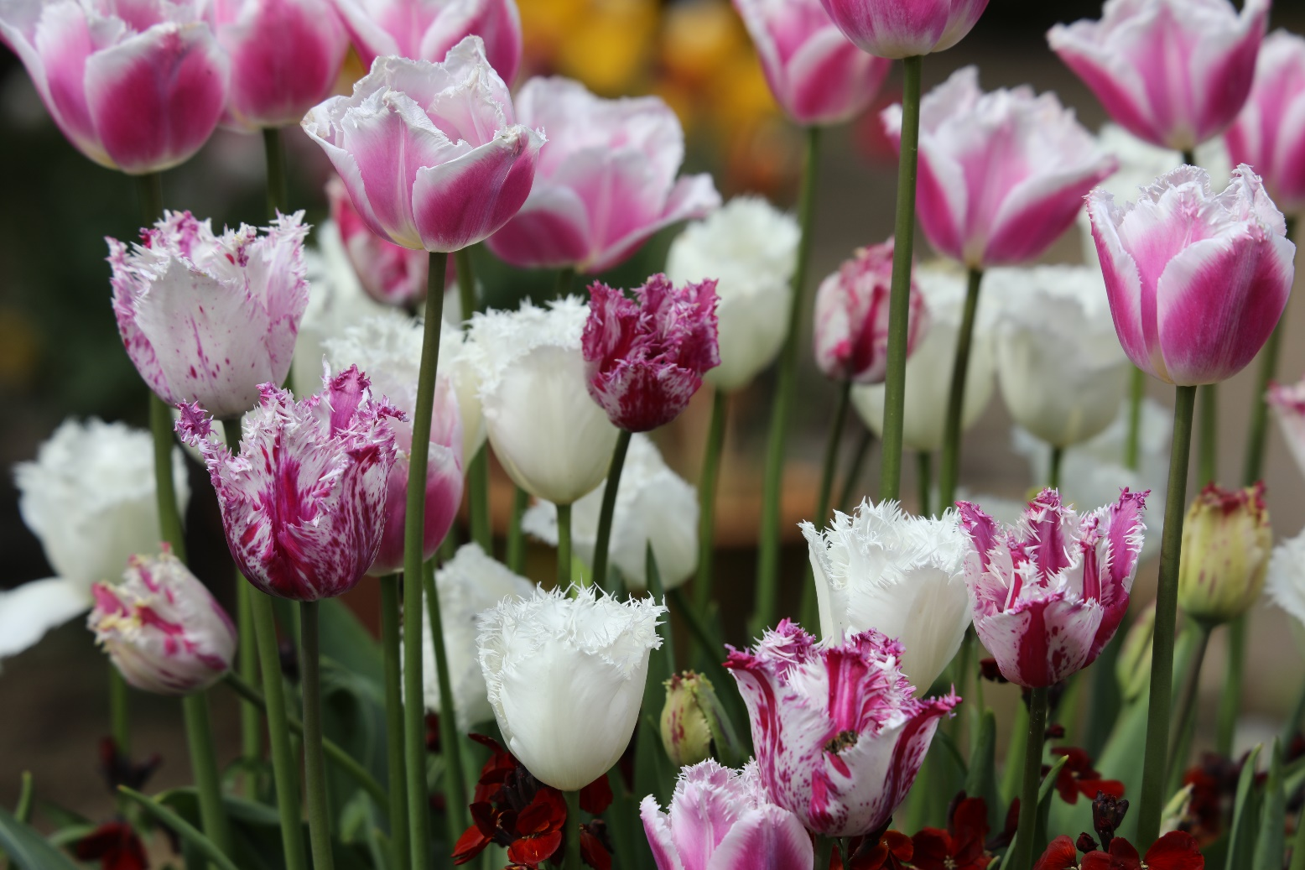

www:horringer-gardening-club.co.uk

New members are always welcome. You don't have to be an avid or knowledgeable gardener, just someone interested in a wide range of gardening and allied topics, although you need not be a member to come to our meetings or exhibit at the Flower Show.

Look out for details of these in the Horringer Diary, our website (www.horringer-gardening-club.co.uk) or on village notice boards. If you would like to join (application forms on website) or require further information please contact any of the committee below.

Chairman & Programme Polly Barfoot
07971 149919
pollybarfoot@aol.com

Vice Chairman Siobhan Richardson
07966 583355
siobhanmr@ymail.com

Treasurer Francis Milne
01284 735440
francis.milne@btinternet.com

The admission charge to our speaker meetings is normally £3.00 for members and £5.00 for visitors except for the A.G.M. when there is no charge. Unless stated otherwise, meetings start at 7.30 pm.

2026
Monday 12th January AGM – Followed by a programme 2026 overview
Monday 16th February Clive Nicols – Photographing Plants & Gardens
Monday 9th March Stella Exley – Camassia’s– Hare Spring Cottage Plants (RHS Master Grower & Chelsea Exhibitor)
Monday 13th April Plant Sales
Tuesday 14th April Holme Hale Hall & Wretham Lodge – Garden Visit
Sunday 3rd May to The Old Rectory, Hall Lane, Brinkley – Garden Visit
Thursday 7th May Open gardens between these dates

Monday 11th May Greg Veness – Delphiniums – The Front Gardeners
Tuesday 12th May Church Cottage, Troston – Garden Visit
Wednesday 3rd June Highgrove – Garden Visit
Monday 8th June Kim O’Brien - Dahlias
TBC Sandringham – Garden Visit
Monday 13th July 139th Annual Flower Show with Quiz
Wednesday 2nd Sept Beth Chatto & Ulting Wick – Garden Visit

Monday 14th September Lynn Moore – 52 weeks in the shade garden – Moore & Moore Plants (Chelsea Exhibitor)
Tuesday 22nd September The Old Rectory, Hall Lane, Brinkley – Garden Visit
Monday 12th October Luci Skinner – Salvia’s, Greenways Beds & Borders
Monday 9th November Chris Beardshaw – Painting with Plants
Monday 14th December Christmas Social Event

About our Gardening Club

The roots of our Gardening Club can be traced back to the first ever Village Flower Show which was held in September 1885. It was held in a tent pitched on what was the quoit ground at the back of the Institute, the house now called ‘The Old Rectory,’ so it must have been on land which is now the children’s playground. It was organised by managers of the Horringer and Ickworth Village Club and Institute or what is now known as Horringer Sports and Social Club.

The Rector, Rev. J. Giddens, acted as secretary and Lord Bristol donated a sum of money to help with prizes and expenses.

Now, some 139 years on the Annual Flower Show is a main event of our year. The show schedule has around 100 classes covering fruit, vegetables and flowers together with sections on floral art, crafts, cookery and photography. There are several silver trophies to be won.

Today the Club has over 150 members all of whom enjoy gardening, fresh air and fun. A number of speaker meetings are held during the year normally on the second Monday of the month on a range of topics of interest to gardeners and ‘outdoor’ people. In summer, visits are organised to gardens of interest in the locality and beyond.

Our Annual General Meeting is usually held in January. Yearly subscription are reviewed annually by the committee, for 2026 the cost is £10 which is due at the beginning of the year. Entrance fees for the meetings together with the raffle profits go towards the cost of our monthly speaker evenings.

www:horringer-gardening-club.co.uk

139th Flower Show
Monday 13th July 2026
Open to all Horringer Garden Club Members. The schedule will be available in early 2026. Many trophy’s to be won:
The Collins Trophy for Fruit | The Friary Cup - Highest No. of Points in Floristry
The Silver Challenge Cup for Vegetables | The Coronation Cup for Preserves
The Brabrook Cup for Garden Flowers | The Joan Whiting memorial Trophy for Cookery
The Silver Rose Bowl for Roses | National Trust Trophy - Highest No. of Points in Photography
The Lainson Cup for Pot plants | National Trust Trophy - Best Exhibit in Photography
Floral Art Cup for Best Exhibit in Floristry | The Bank Cup for Crafts

Speaker Evenings
Monday 9th March 2026
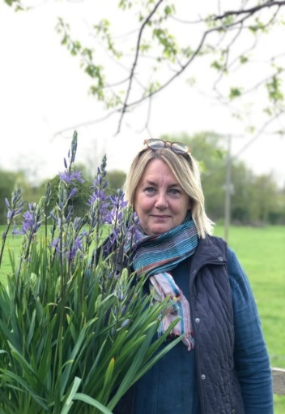
Stella Exley – Camassia’s – Hare Spring Cottage Plants
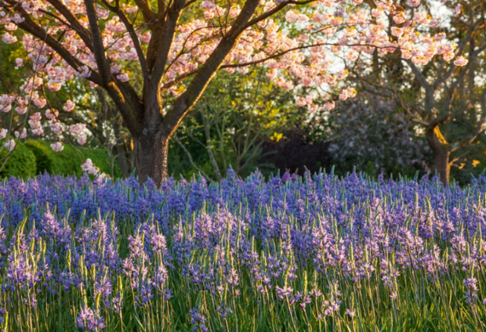
Stella Exley Stella has loved plants from an early age and pursued her love to set up Hare Spring Cottage Plants in Yorkshire.
She became very successful, exhibiting widely, giving talks nationwide and winning awards.
In September 2022 she took a chance and relocated to Devon, moving home and nursery to a 2 acre garden and woodland near Kingsbridge.
Today, she regularly exhibits in floral marquees at major horticultural shows and is the proud holder of three National Plant Collections® – camassia, sidalcea and uvularia – and Royal Horticultural Society (RHS) Chelsea Flower Show gold medals.

Monday 13th April 2026 – Annual Plant Sales
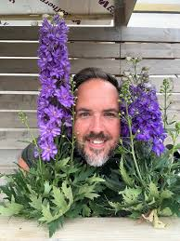
Monday 11th May 2026
Greg Veness - Delphiniums
Greg Veness runs his business The Front Gardeners from the Willow Tree Farm Shop in Glemsford, Suffolk. Greg will be sharing his extensive knowledge about Delphiniums.
He cultivate a wide variety of perennial, biennial and annual
plants but his passion is Delphiniums. He attends may local fairs and he is now open to the public.

Monday 8th June 2026
Kim O’Brien - Dahlias
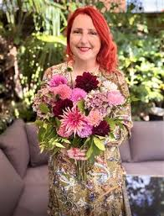
Kim‘s first garden transformation was her own Cambridge city garden which she renovated from a blank canvas to an elaborate floral haven 23 years ago. Her design incorporated, a myriad of flowers, including dahlias; which she left behind when she moved to Toronto, Canada. Fast forward 20 years; and back on UK soil; Kim’s love for dahlias reignited with a passion, and she now boasts a collection of over 200 varieties at her home, field and allotment.
Kim’s success as a flower grower has catapulted her to expert status in the area of dahlias in recent years
An accomplished floral designer, Kim works at a top Cambridge floristry company, meaning she gets to flex her creative muscle on a daily basis.
Kim is a gardener, grower and floral designer at a top studio in Cambridge. She has hosted floristry workshops for BBC Gardeners World and a regular speaker at Gardeners World Live, Spring and Autumn shows. She is also a Garden Designer and won a Gold Medal for her first show garden at BBC Gardeners World Autumn Fair.

Monday 14th September 2026
Lynne Moore – 52 Weeks in the Shade garden Moore & Moore Plants
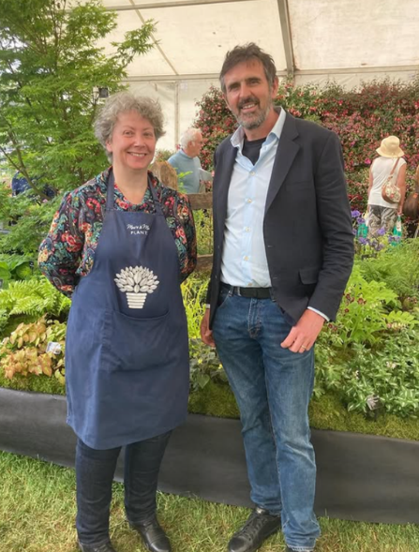
Moore & Moore Plants are a Chelsea Gold Medal winning, small, independent, family run nursery based in Billericay, Essex.
They specialise in shade tolerant and woodland plants but also have a choice selection of plants which are a magnet for pollinating insects.
Lynne has gardened for as long as she can remember. Her first memories are picking snowdrops from her grandparents garden (snowdrops are still a favourite). Always encouraged by her grandad Jack, her knowledge and enthusiasm grew until such times that she had her own little garden at her first flat.
Grandad duly propagated a number of plants to fill this little plot, many of which Lynne still has today in her current garden. "Without my Grandad I wouldn't be doing what I am. I owe him so much.
Lynne gave up working as a Senior Fingerprint Expert in the Metropolitan Police Forensic Directorate in February 2016 after 25 years service to work with the plants full time. "I love what I do. I'm so lucky."
Monday 12th October 2026 – Luci Skinner – Salvia’s
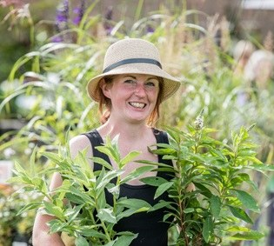
Exploring one of the largest genera of plants including the Old-World hardy forms and the flamboyant New World forms. Selecting which forms are best for your garden and learning how to grow Salvias successfully.
Luci has worked in horticulture for 15 years. She is a former manager and Director of Woottens Nursery in Wenhaston, where she ran the propagation schedules for the nursery including the rare Pelargonium collection for which she holds the National Collection status for, jointly with the nursery.
She now runs her own gardening and plant advice business and has been giving talks for 10 plus years on a variety of different genus.

Monday 9th November 2026
Chris Beardshaw – Painting with Plants
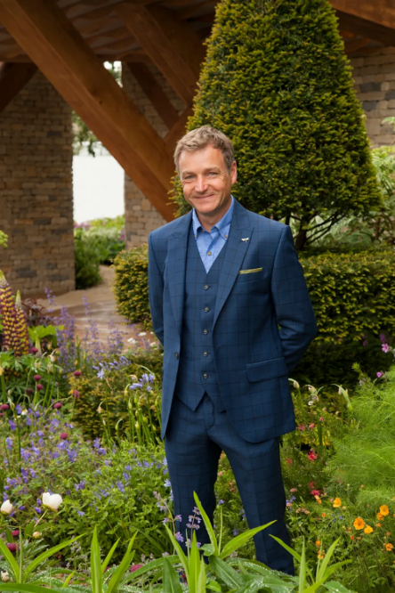
Chris Beardshaw is one of the UK’s most celebrated garden and landscape designers, renowned for his award-winning creations, distinctive planting style, academic depth, and eloquent media presence.
A familiar face to millions, Chris began his broadcasting career in 1997. He has since become a staple on BBC television, with popular series including Gardeners’ World, Hidden Gardens, and The Flying Gardener, among others. He’s also a regular panellist on BBC Radio 4’s Gardeners' Question Time, engaging live audiences of enthusiastic gardeners.
As founder and creative director of Chris Beardshaw Design, he has led the creation of RHS Gold Medal-winning gardens, private estates, and landmark public landscapes.
Chris will talk through the evolution of the English Garden style, in particular the development of the herbaceous border, from the earliest incarnations through to 21st century examples.
He describes the key exponents of the style, the design approaches, and lessons behind the artistry so that you feel empowered to combine plants and create your own stunning border.
Monday 14th December 2026 – Christmas Social
ALL GARDEN VISITS FOR 2026 (DETAILS AND COSTS) WILL BE EMAILED TO MEMBERS

